AUTHORITY TO CHARGE

I, <<CARD HOLDER NAME>> am authorizing <<Philippine Institute of Certified Public Accountants, Inc. (PICPA)>> to charge my credit card <<TRANSACTION AMOUNT>> as payment for <<Seminar/Training Fee>>. Below are my Credit Card Details:
____ Visa
____ MasterCard

Seminar Topic: _____________________________________________________________
Seminar Date: ______________________________________________________________
Chapter: ___________________________________________________________________
Issuing Bank: _______________________________________________________________
Credit Card Number __________________________________________________________
Expiry Date _________________________________________________________________
BIN (Four Digit printed under the Credit Card Number) ____________________________

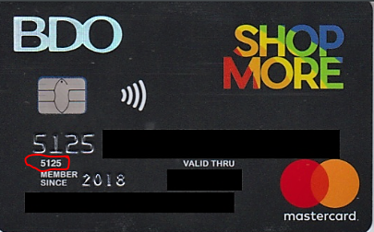

______________________________________ __________________
Card Holder Signature Date

